**East West University**

**Department of CSE**

|  |  |  |
| --- | --- | --- |
| **Course Code and Name:**  Electrical Circuit (CSE209) | | |
| **Experiment no:**  06 | | |
| **Experiment name:**  Verification of Thevenin’s theorem | | |
| **Semester and Year:**  Fall 2021 |  | |
| **Name of Student:**  D.M. Rafiun-Bin-Masud  **Student Id:**  2019-3-60-137 | **Course Instructor information:**  M Saddam Hossain Khan Senior Lecturer, Department of Computer Science and Engineering | |
| **Date of Report Submitted:**  29 December,2021 | **Pre-Lab Marks:** |  |
| **Post Lab Marks:** |  |
| **TOTAL Marks:** |  |

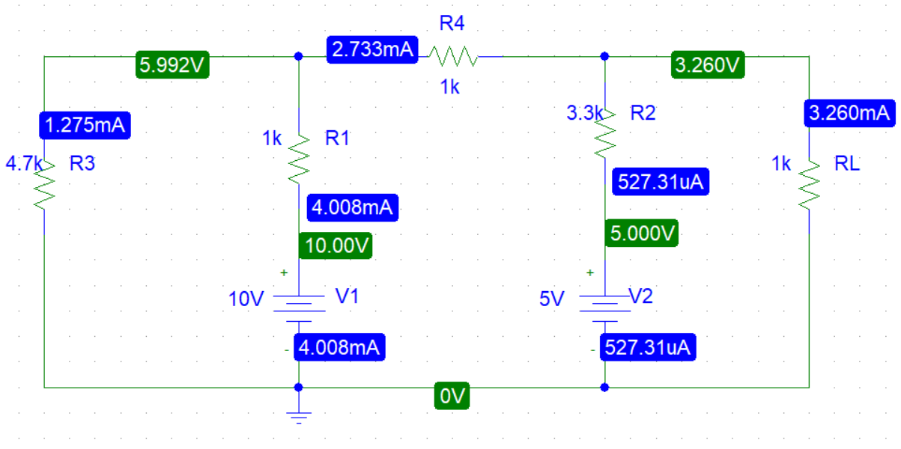**Circuit diagram:**

**Figure-1**

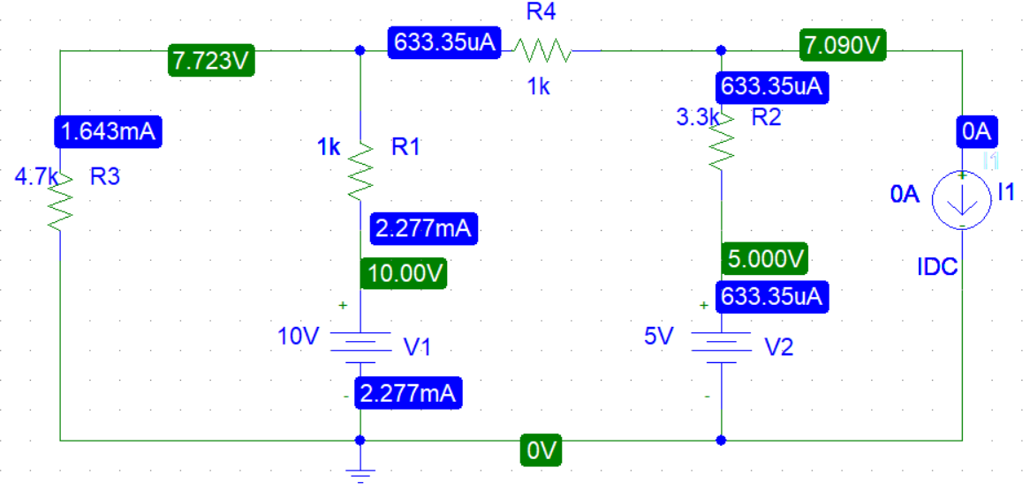

**Figure-2**

In figure 2,

Voc = 7.090 V

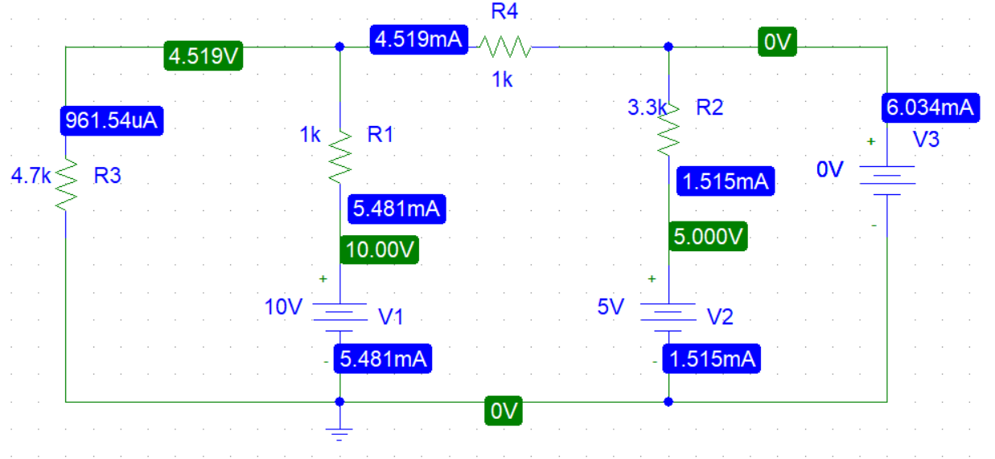

**Figure-3**

In figure 3,

Isc = 6.034 mA

Rth = Voc/ Isc

= 1.175k

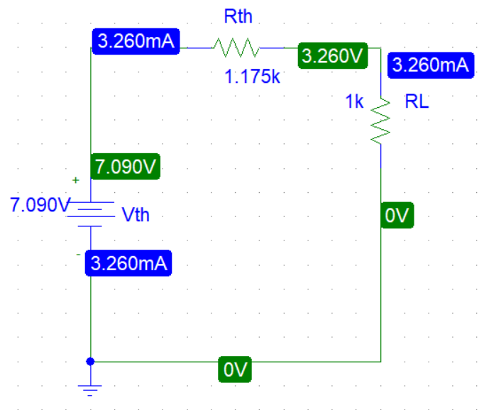

**Figure-4**

From Fig-1 and Fig-2,

We see this is the Thevenin’s theorem verified.

**Experimental Datasheet:**

**Table 1:**

|  |  |  |  |  |  |  |
| --- | --- | --- | --- | --- | --- | --- |
| Measured Value of E1 | Measured Value of E2 | Measured Value of VL | Measured Value of IL | Measured Value of VOC | Measured Value of ISC | Measured Value of resistors (KV) |
| 10 V | 5 V | 3.258 mA | 3.3 mA | 7.130 V | 6.10 mA | R1 = 0.985  R2 =3.27  R3 =4.60  R4 =0.989  RL =0.982 |

**Comparing the theoretical calculate values with the experimental values:**

**Table 2:**

|  |  |  |  |  |  |
| --- | --- | --- | --- | --- | --- |
|  | VL (V) | I(mA) | VOC (V) | ISC (mA) | RTH (V) |
| Calculated | 3.24 | 3.30 | 7.08 | 6.10 | 1161 |
| Measured | 3.258 | 3.30 | 7.13 | 6.10 | 1169 |
| Error | 0.5% | 0% | 0.7% | 0% | 0.7% |

From Figure-1 and Figure-2,

We see this is the Thevenin’s theorem verified

**Pre-Lab:**

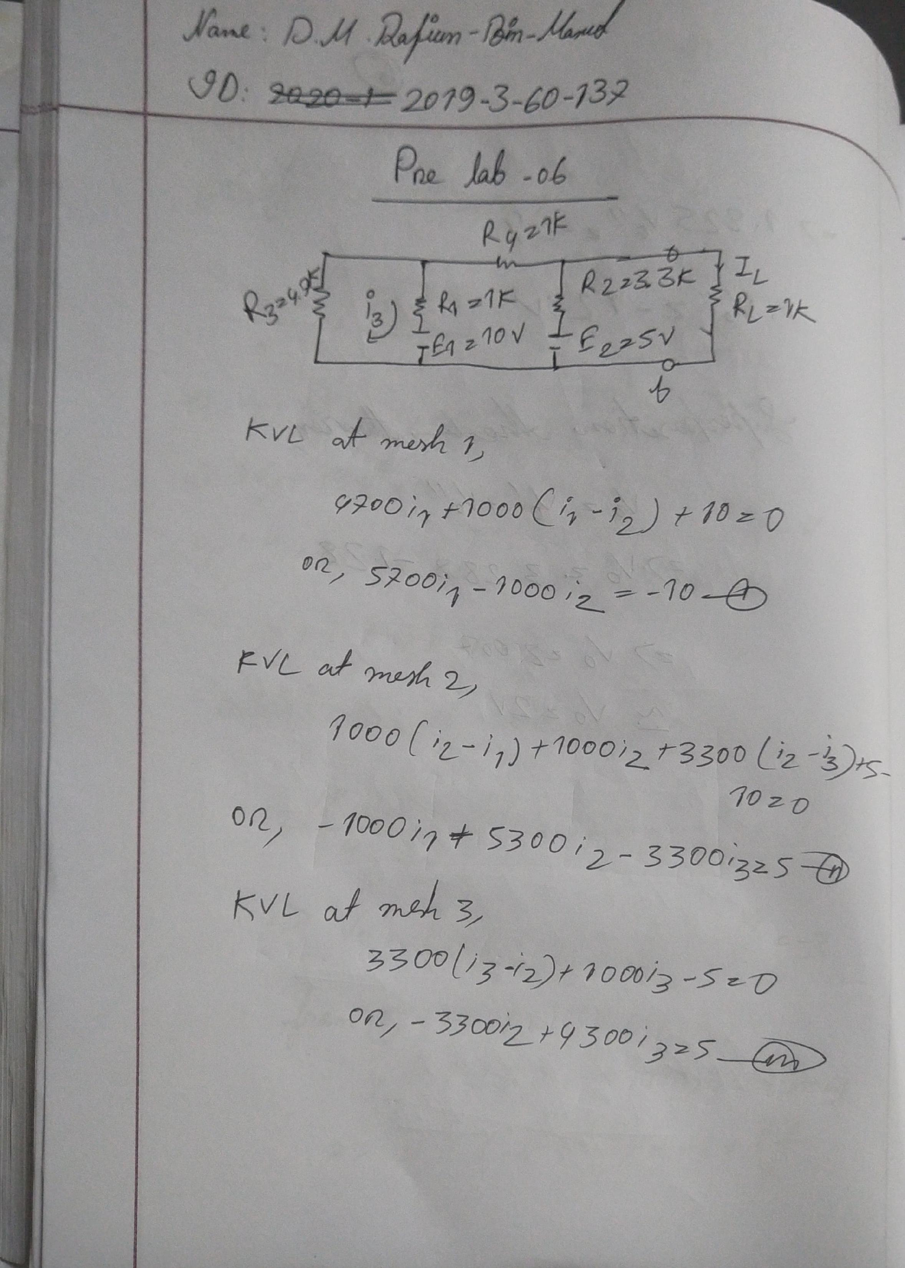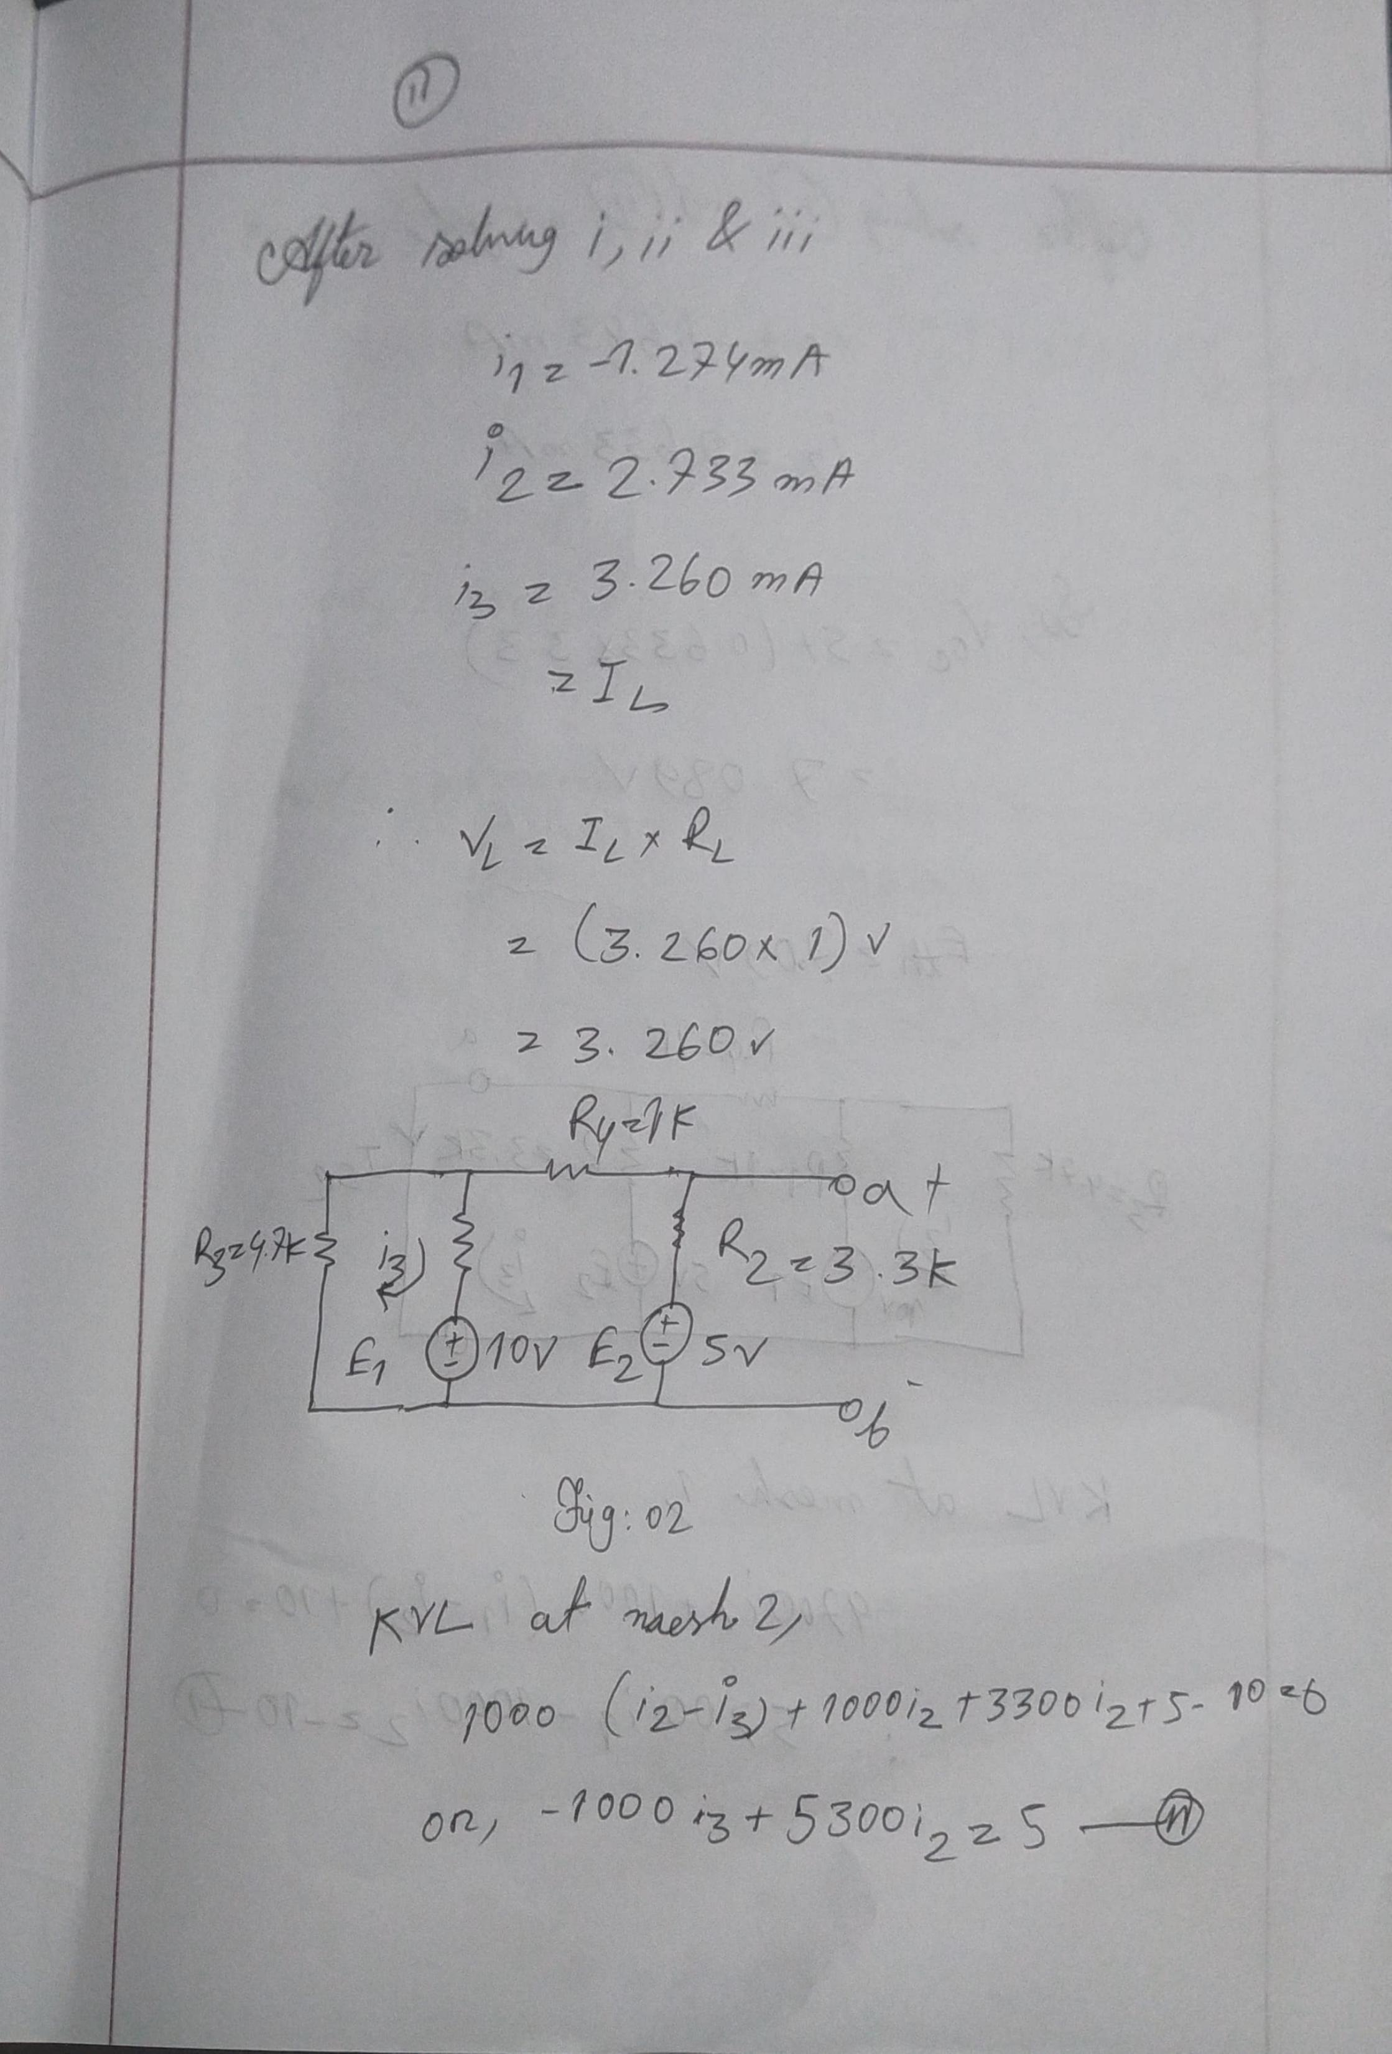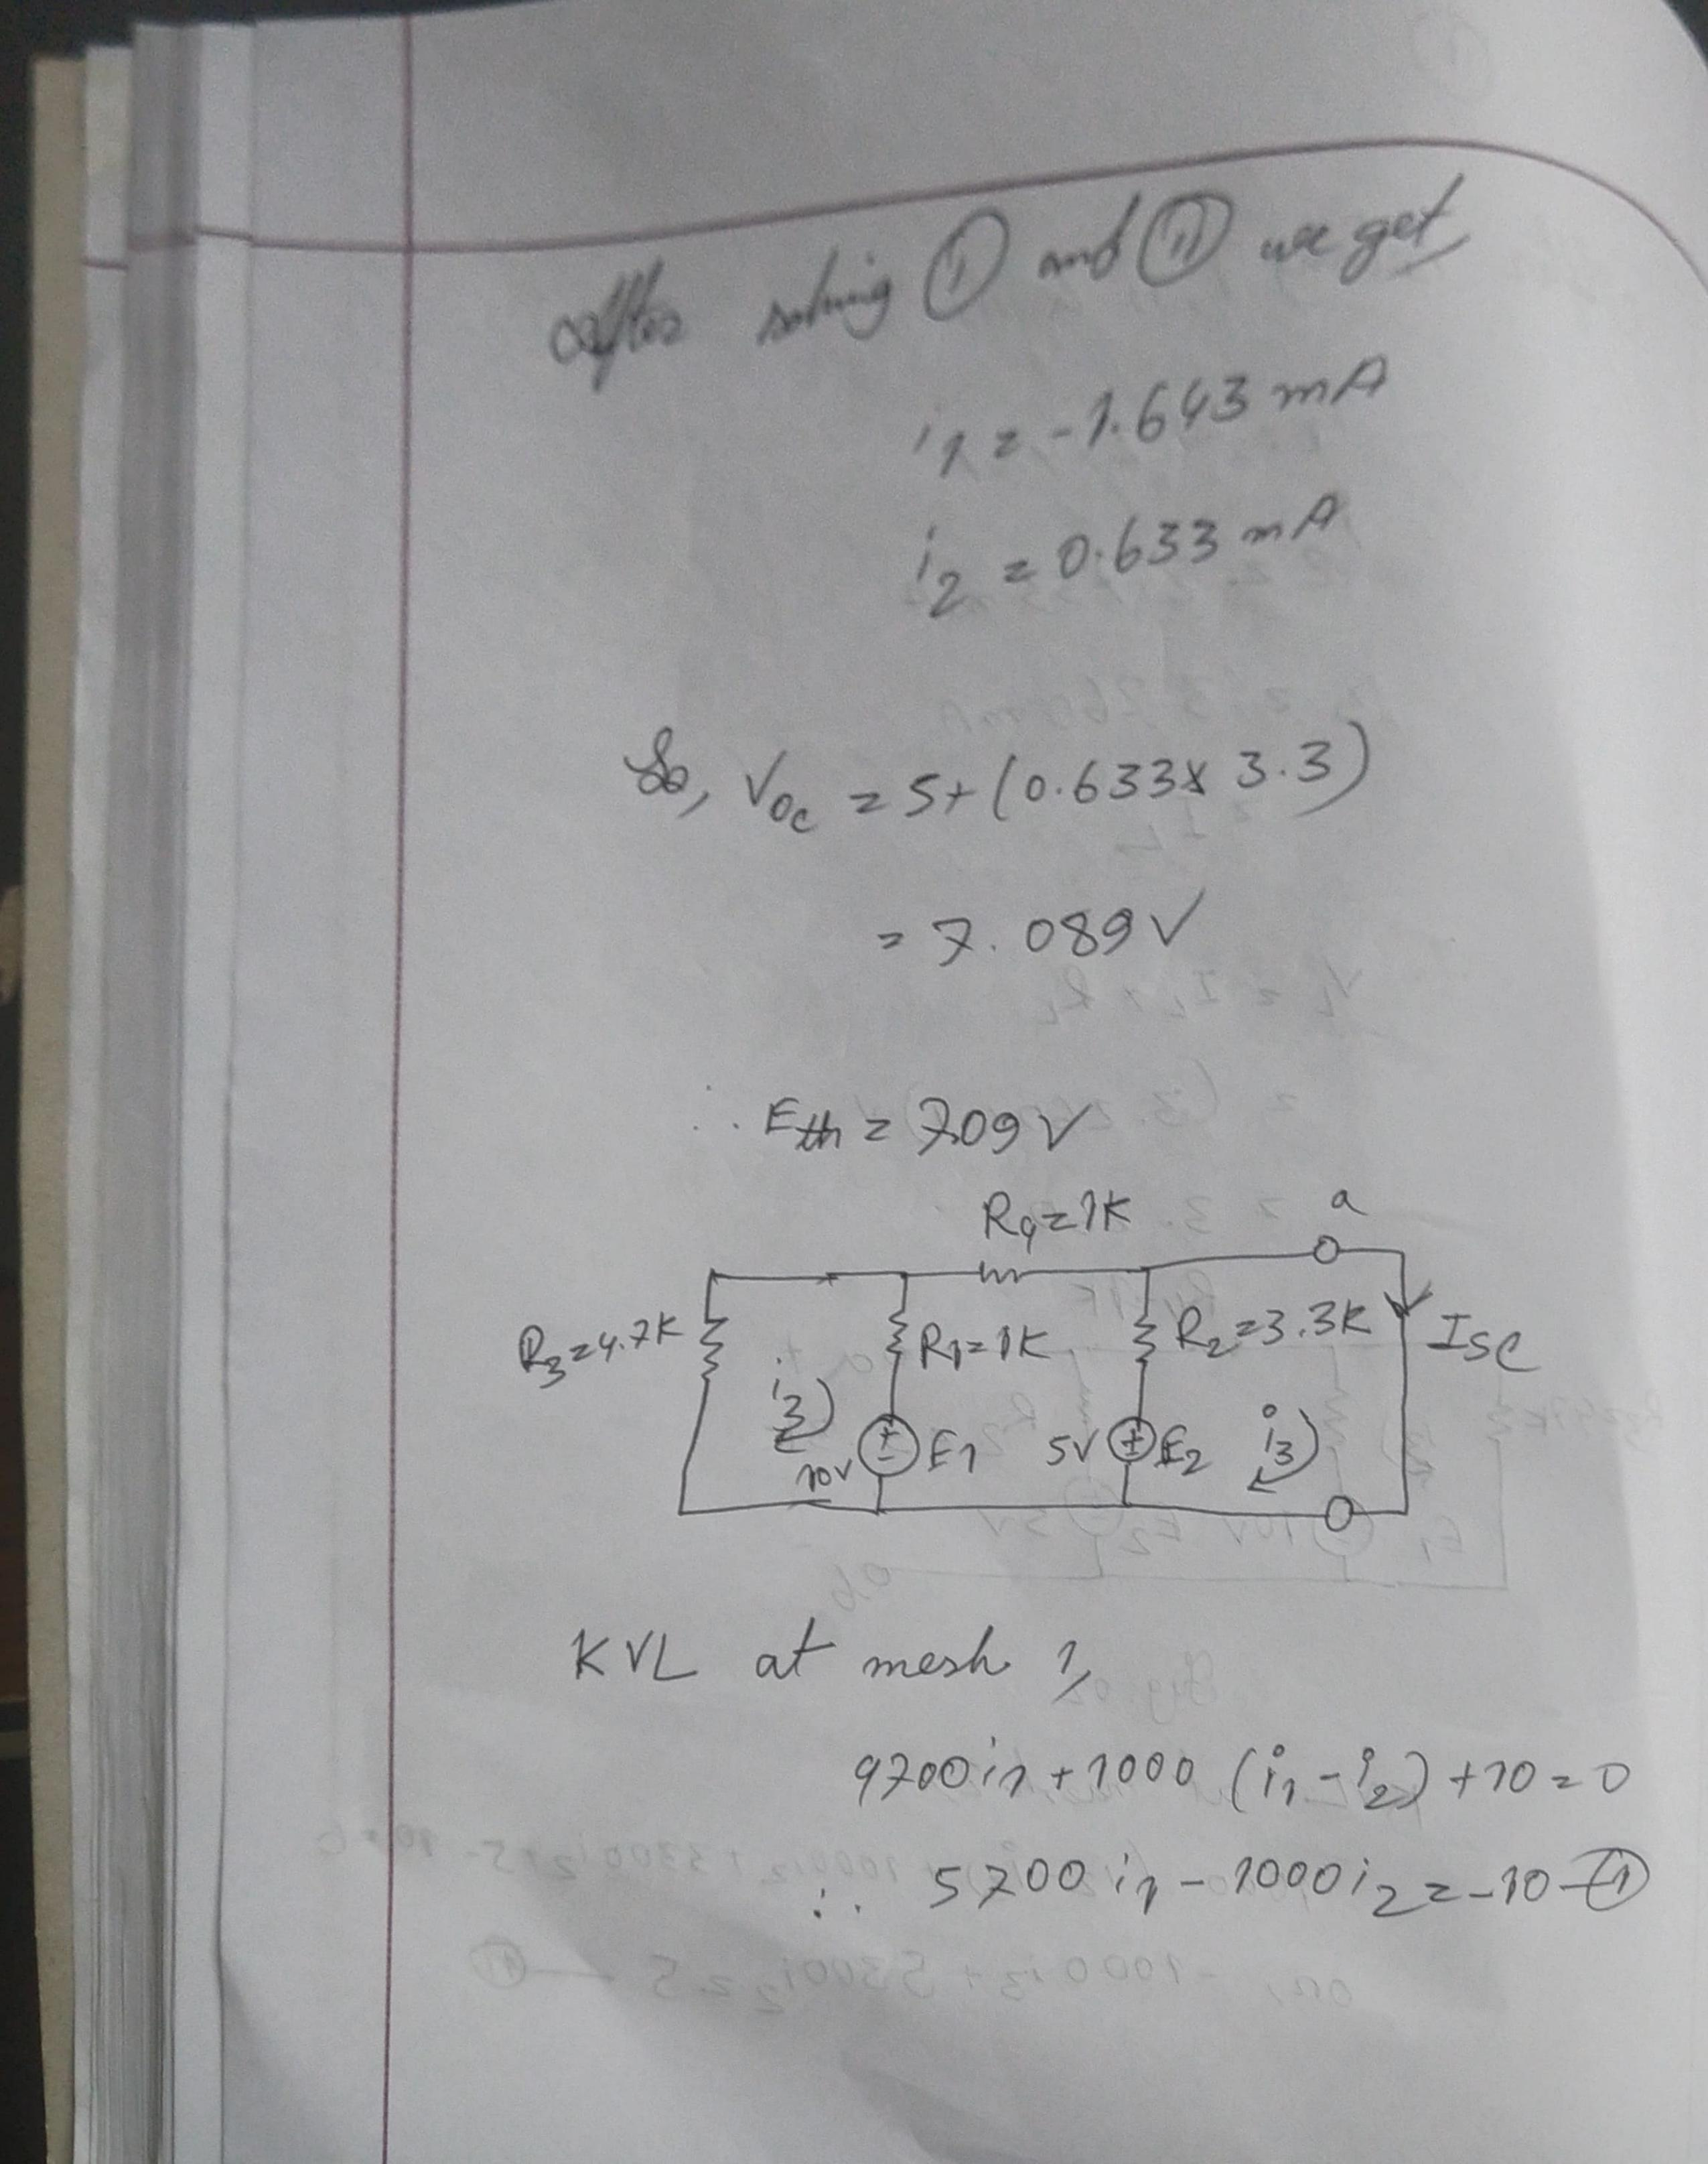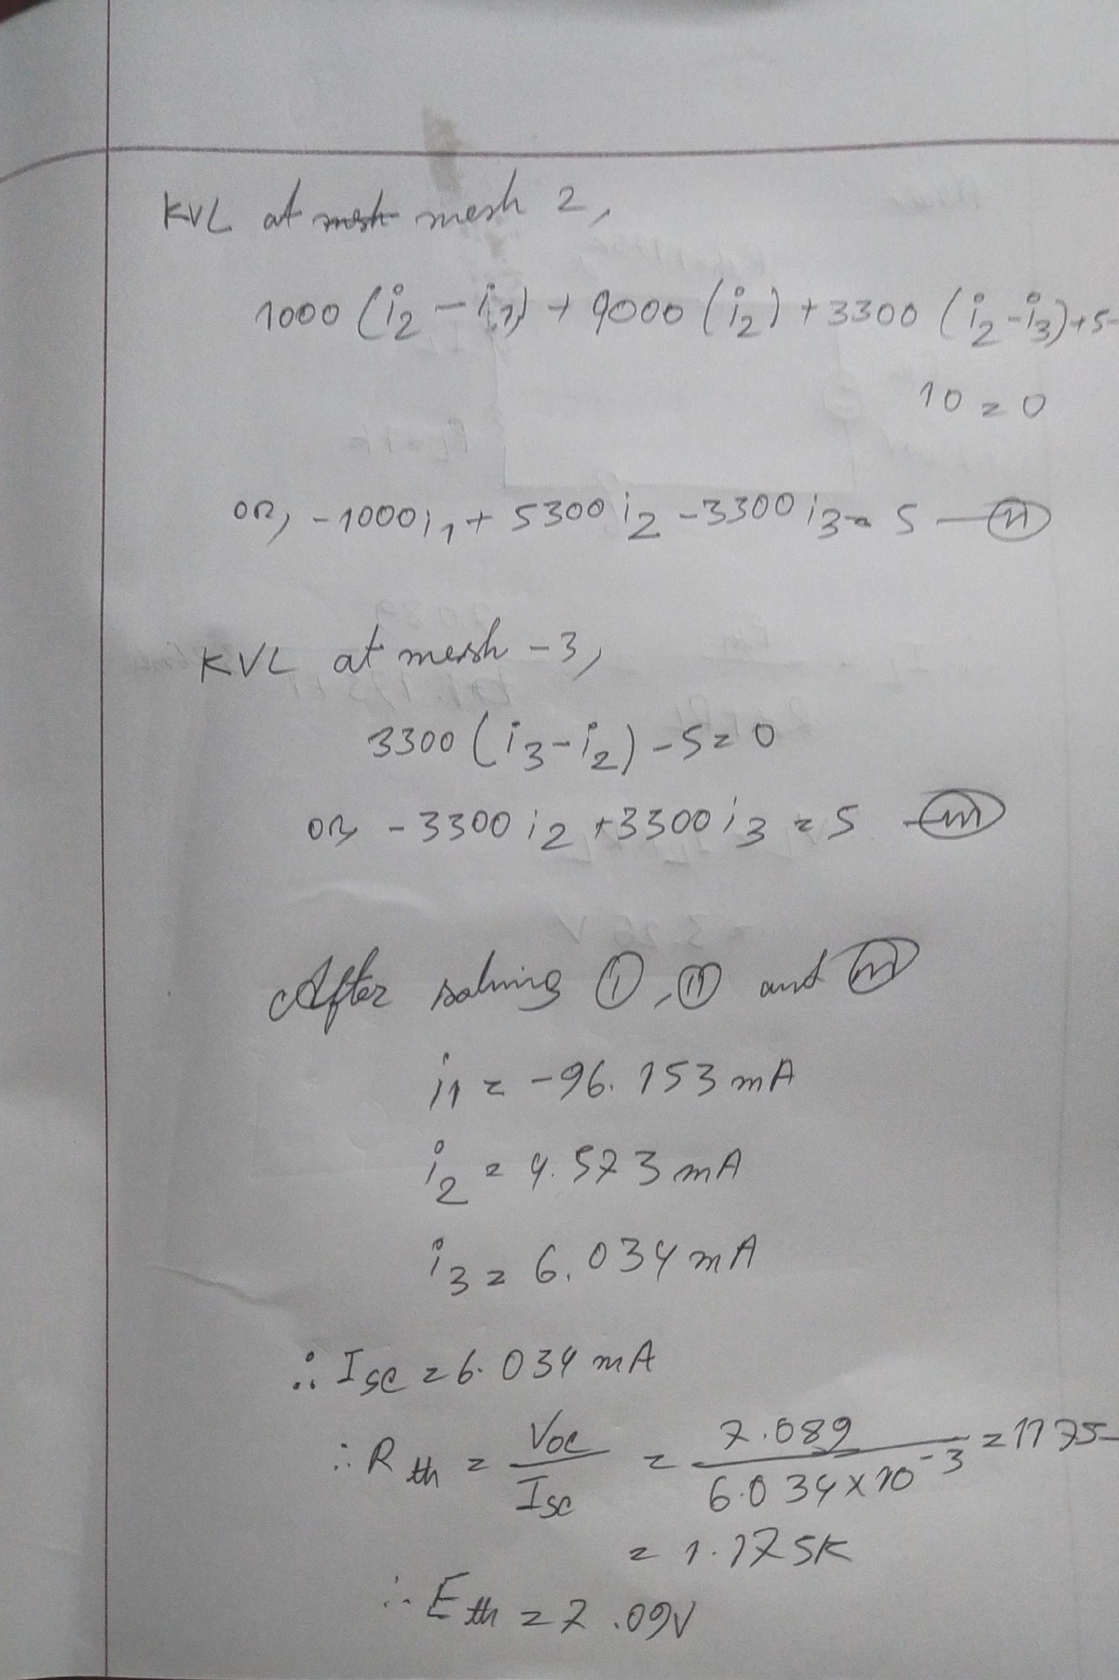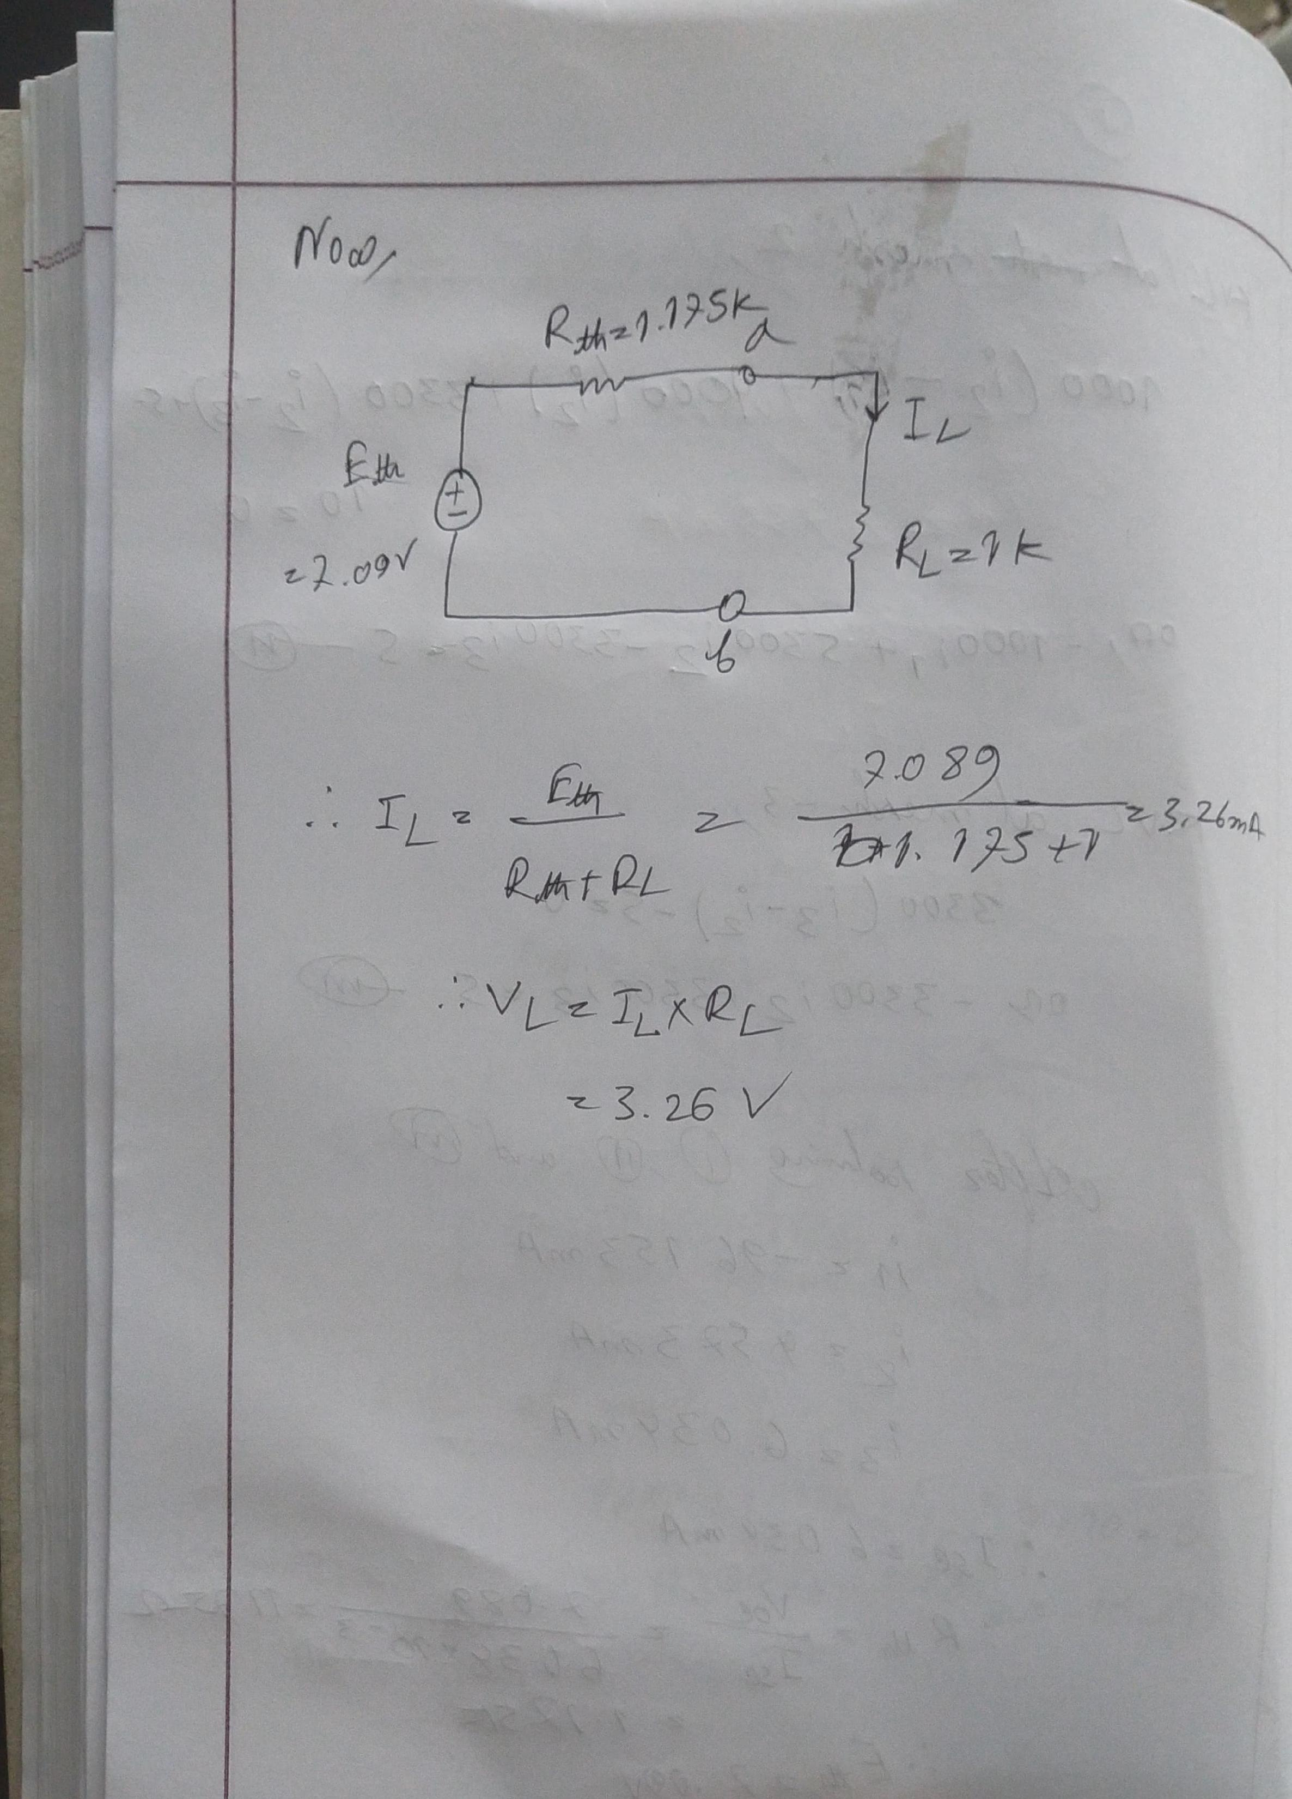

**POST LAB**

**For fig 1,**

KVL in mesh 1,

4700i1 + 1000(i1-i2) = -10

* 5700i1 - 1000i2 = -10…………….(1)

KVL in mesh 2,

1000(i2 – i1) + 1000i2 + 3300(i2 – i3) =10-5

* -1000i1 + 5300i2 -3300i3 = 5……..(2)

KVL in mesh 3,

3300(i3 – i2) + 1000i3 = 5

* -3300i2 + 4300i3 =5……………..(3)

From (1), (2) and (3)

i1 = -1.274mA

i2 = 2.733mA

i3 = 3.260mA

IL = 3.260mA

VL = IL * RL = (3.260 * 10-3 *1000)

= 3.260V

**For fig 2,**

KVL in mesh 1,

4700i1 + 1000(i1-i2) = -10

* 5700i1 – 1000i2 = -10……….(1)

KVL in mesh 2,

1000(i2 – i1) + 1000i2 + 3300i2 = 10.5

* -1000i1 + 5300i2 = 5 ………..(2)

From (1) (2),

i1 = -1.643mA

i2 = 0.633mA

VOC = (5 + 0.633*10-3 * 3300)V

= 7.089V

**For fig 3,**

KVL at mesh 1,

4700i1 + 1000(i1 – i2) = -10

* 5700i1 – 1000i2 = -10…………(1)

KVL at mesh 2,

1000(i2 – i1) + 1000i2 + 3300(i2 – i3) = 10 – 5

* -1000i1 + 5300i2 -3300i3 = 5…..(2)

KVL at mesh 3,

3300(i3 – i2) = 5

* -3300i2 + 3300i3 = 5……………(3)

From (1), (2) and (3)

i1 = -96.153mA

i2 = 4.573mA

i3 = 6.034mA

ISC = 6.034mA

Rth = Voc/Isc = 7.089/6.034*10­-3

=1.175kΩ

Eth = 7.089V

**For fig 4,**

IL = (E­th/ Rth) + RL

= 7.089/1175 + 1000

= 3.259 mA

VL = RL * IL

= (1000 * 3.259*10-3)

= 3.259V

So, Thevenin’s theorem verified.

**2.**

|  |  |
| --- | --- |
| Theoretically calculated values | PSpice Simulation values |
| IL = 3.260mA (Fig-1) | IL = 3.260mA (Fig-1) |
| VL = 3.260V (Fig-1) | VL = 3.260V (Fig-1) |
| Voc = 7.089V | Voc = 7.090 V |
| ISC = 6.034mA | ISC = 6.034mA |
| Rth= 1175Ω | Rth= 1175 |
| IL = 3.260mA (Fig-4) | IL = 3.260mA (Fig-4) |
| VL = 3.260V (Fig-4) | VL = 3.260V (Fig-4) |

There is no discrepancy in PSpice simulated values and the calculated values.

**3.**

By simulating those 4 circuits we got the values of VL, IL, VOC, ISC, Rth, Eth and got the same values by calculation which are same. So, the Thevenin’s Theorem is verified.

**CONCLUSIONS**

From this experiment we learnt how to use Thevenin’s theorem and also verified the Thevenin’s theorem by the measured data and the calculated data.